Udział w wojewódzkich Igrzyskach dzieci w lekkiej atletyce

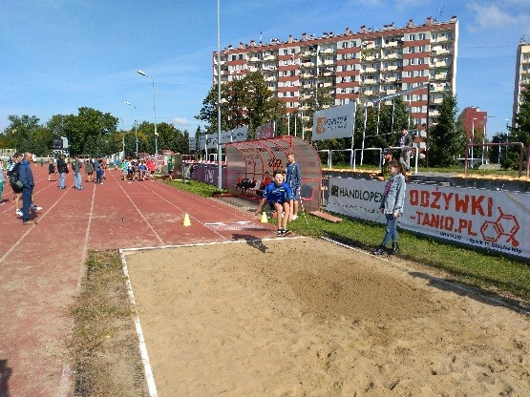
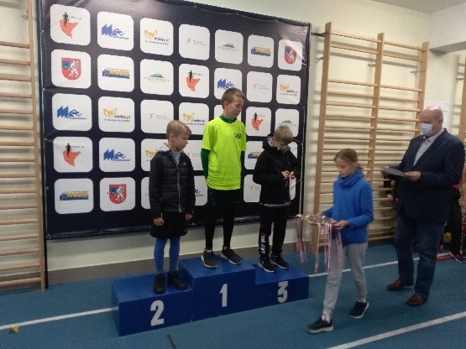

https://spborowa.edupage.org/news/?eqa=d2lkPW5ld3NfTmV3c18xX3AmbmV3c2FyY2hpdmVmPSZvZmZzZXRfbmV3c19OZXdzXzFfcD00MA%3D%3D

Akademia Małych Zdobywców

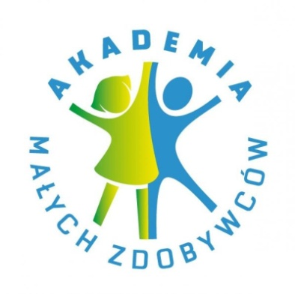
https://spborowa.edupage.org/news/?eqa=d2lkPW5ld3NfTmV3c18xX3AmbmV3c2FyY2hpdmVmPSZvZmZzZXRfbmV3c19OZXdzXzFfcD00MA%3D%3D

SP! SERCE I POMOC

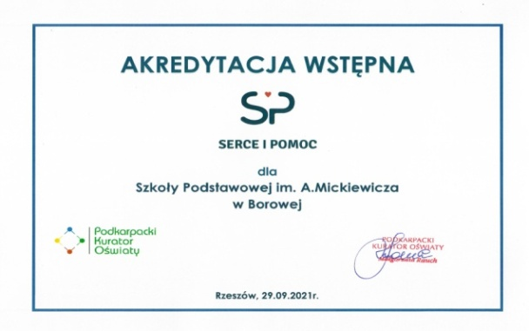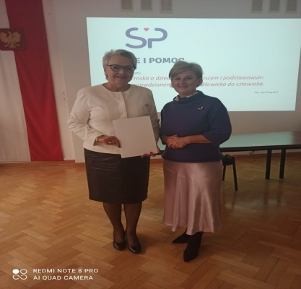

https://spborowa.edupage.org/news/?eqa=d2lkPW5ld3NfTmV3c18xX3AmbmV3c2FyY2hpdmVmPSZvZmZzZXRfbmV3c19OZXdzXzFfcD00MA%3D%3D

Ogólnopolski Dzień Głośnego Czytania

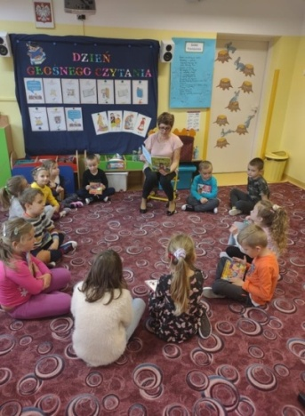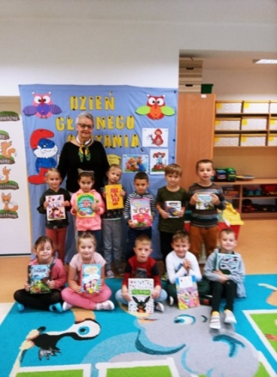
https://spborowa.edupage.org/news/?eqa=d2lkPW5ld3NfTmV3c18xX3AmbmV3c2FyY2hpdmVmPSZvZmZzZXRfbmV3c19OZXdzXzFfcD02MA%3D%3D
III b na pieszej wycieczce do pobliskiego lasu

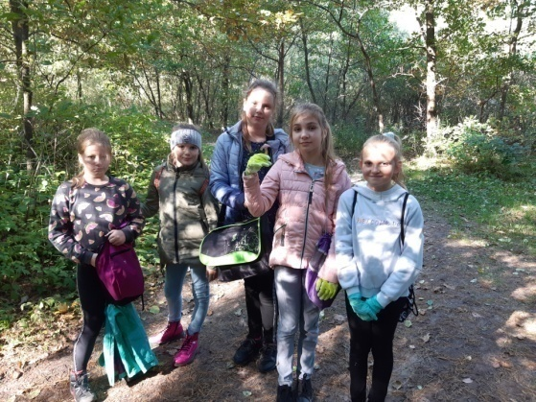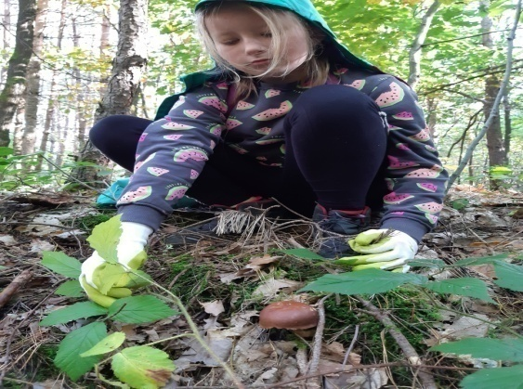
https://spborowa.edupage.org/news/?eqa=d2lkPW5ld3NfTmV3c18xX3AmbmV3c2FyY2hpdmVmPSZvZmZzZXRfbmV3c19OZXdzXzFfcD02MA%3D%3D

Dzień Piżamy

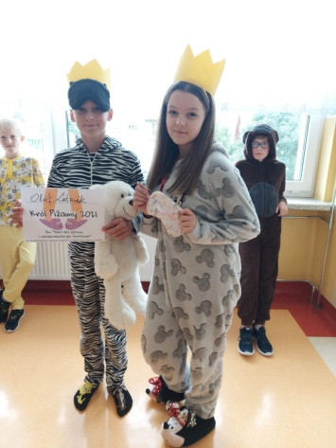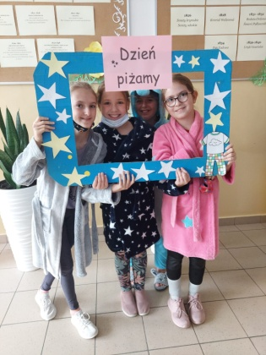
https://spborowa.edupage.org/news/?eqa=d2lkPW5ld3NfTmV3c18xX3AmbmV3c2FyY2hpdmVmPSZvZmZzZXRfbmV3c19OZXdzXzFfcD02MA%3D%3D

Projekt Czysta Polska 2021 klas IV w Akcji sprzątania świata

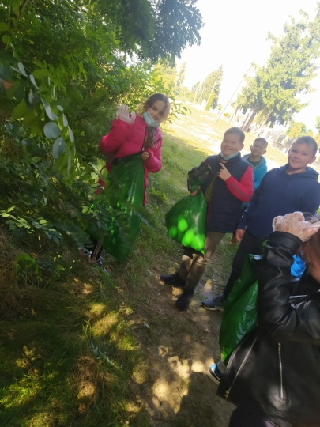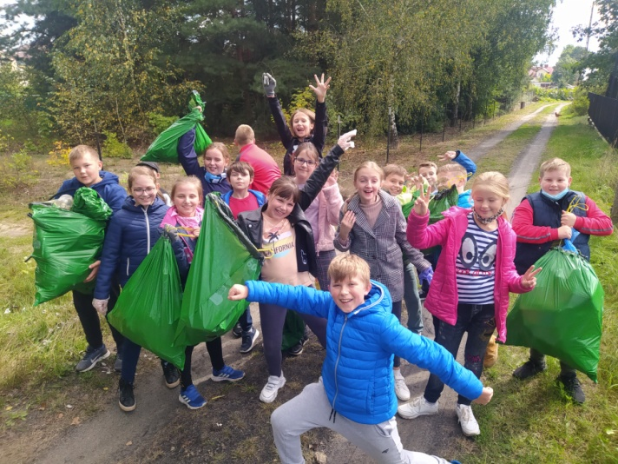
https://spborowa.edupage.org/news/?eqa=d2lkPW5ld3NfTmV3c18xX3AmbmV3c2FyY2hpdmVmPSZvZmZzZXRfbmV3c19OZXdzXzFfcD02MA%3D%3D

Tydzień wychowania obchodzony w dniach 12-18 września 2021
pod hasłem "W blasku ojcostwa"

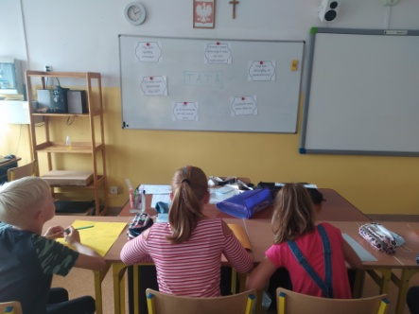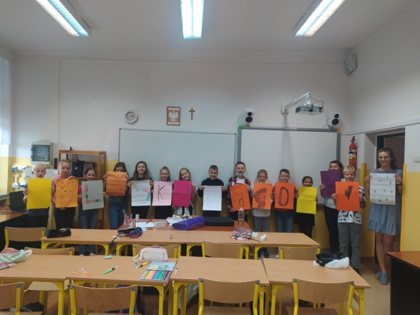
https://spborowa.edupage.org/news/?eqa=d2lkPW5ld3NfTmV3c18xX3AmbmV3c2FyY2hpdmVmPSZvZmZzZXRfbmV3c19OZXdzXzFfcD02MA%3D%3D

Klasy ósme na wycieczce do Muzeum Auschwitz – Birkenau

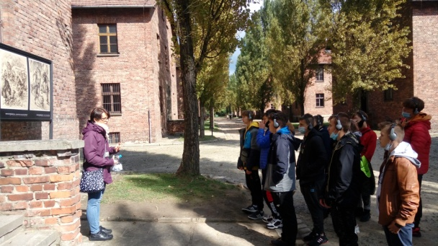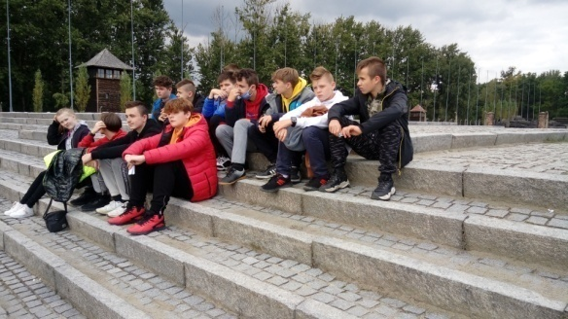

https://spborowa.edupage.org/news/?eqa=d2lkPW5ld3NfTmV3c18xX3AmbmV3c2FyY2hpdmVmPSZvZmZzZXRfbmV3c19OZXdzXzFfcD02MA%3D%3D
Dzień Przedszkolaka

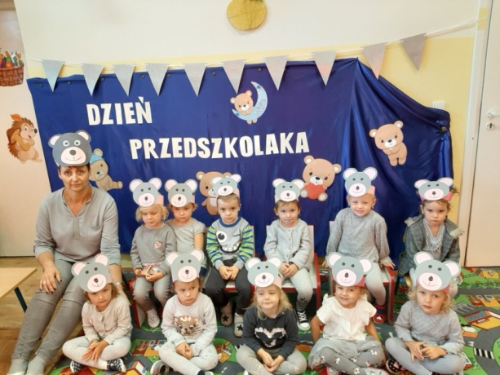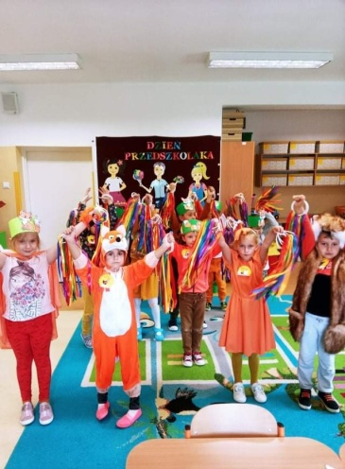
https://spborowa.edupage.org/news/?eqa=d2lkPW5ld3NfTmV3c18xX3AmbmV3c2FyY2hpdmVmPSZvZmZzZXRfbmV3c19OZXdzXzFfcD02MA%3D%3D

Hubert Piątkowski mistrzostwo powiatu mieleckiego w skoku w dal
i awans do Wojewódzkich Igrzysk Dzieci w Rzeszowie

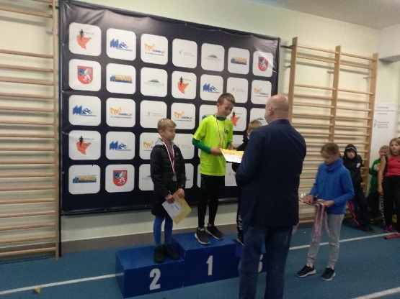
https://spborowa.edupage.org/news/?eqa=d2lkPW5ld3NfTmV3c18xX3AmbmV3c2FyY2hpdmVmPSZvZmZzZXRfbmV3c19OZXdzXzFfcD02MA%3D%3D

Turniej Piłki Nożnej o Puchar Wójta Gminy Borowa

https://spborowa.edupage.org/news/?eqa=d2lkPW5ld3NfTmV3c18xX3AmbmV3c2FyY2hpdmVmPSZvZmZzZXRfbmV3c19OZXdzXzFfcD02MA%3D%3D
Szkolne Koło Turystyczne

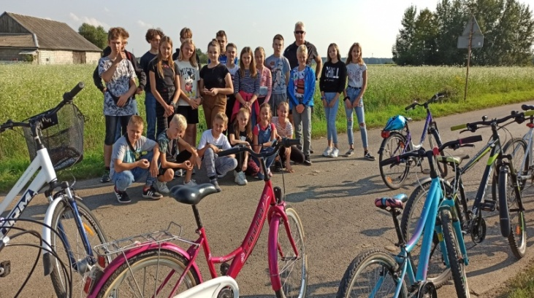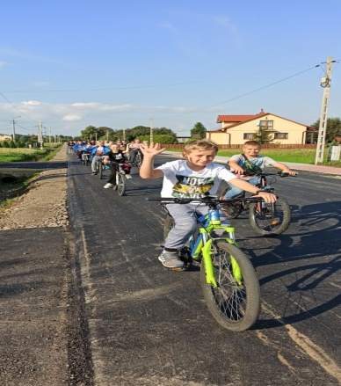
https://spborowa.edupage.org/news/?eqa=d2lkPW5ld3NfTmV3c18xX3AmbmV3c2FyY2hpdmVmPSZvZmZzZXRfbmV3c19OZXdzXzFfcD02MA%3D%3D

Narodowe czytanie „Moralność Pani Dulskiej” G. Zapolskiej

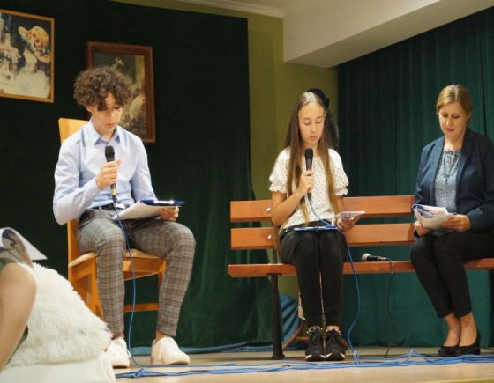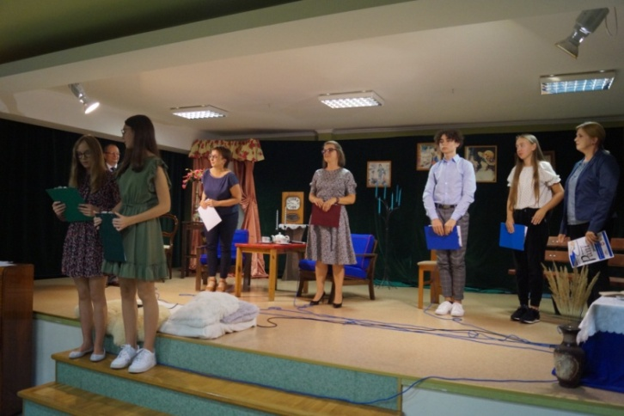
https://spborowa.edupage.org/news/?eqa=d2lkPW5ld3NfTmV3c18xX3AmbmV3c2FyY2hpdmVmPSZvZmZzZXRfbmV3c19OZXdzXzFfcD02MA%3D%3D

Zielony poranek w świetlicy szkolnej

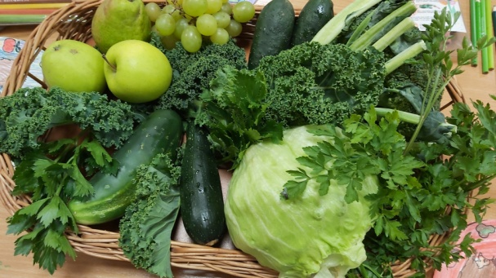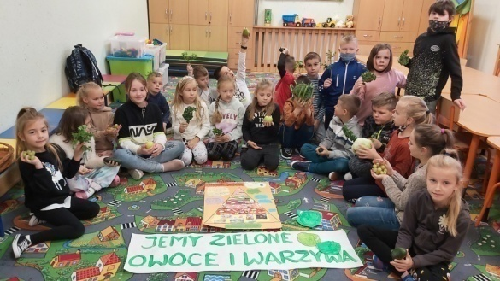

Dzień Kropki

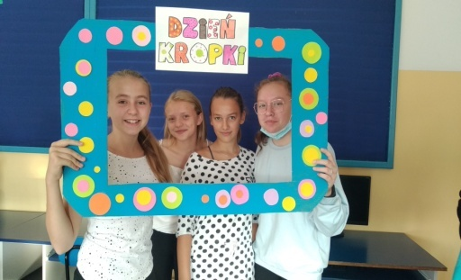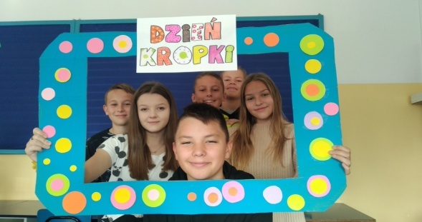

https://spborowa.edupage.org/news/?eqa=d2lkPW5ld3NfTmV3c18xX3AmbmV3c2FyY2hpdmVmPSZvZmZzZXRfbmV3c19OZXdzXzFfcD02MA%3D%3D

Familiada- integracja zespołów klasowych

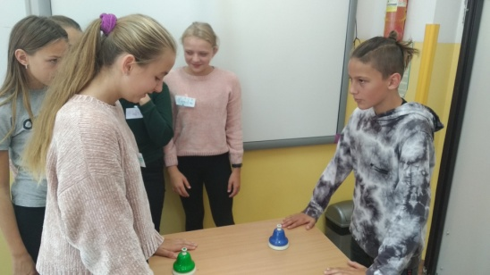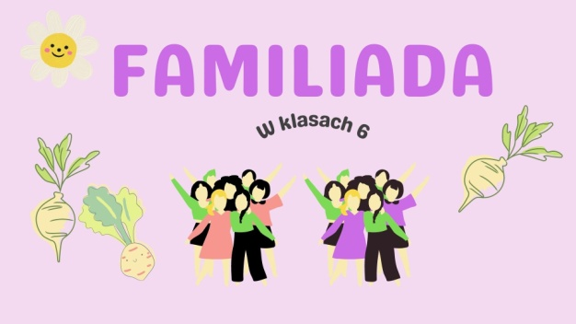
https://spborowa.edupage.org/news/?eqa=d2lkPW5ld3NfTmV3c18xX3AmbmV3c2FyY2hpdmVmPSZvZmZzZXRfbmV3c19OZXdzXzFfcD02MA%3D%3D

