Kultywowanie tradycji
Mikołajkowy wyjazd „MISIÓW” I „SÓWEK”

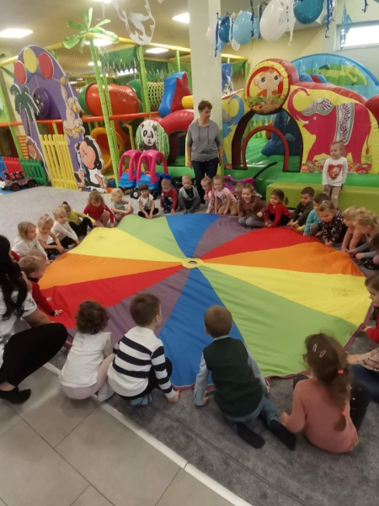
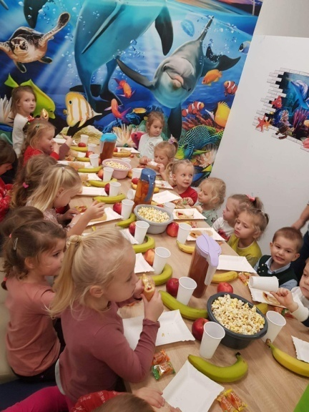

https://cloud-d.edupage.org/cloud?z%3Afh0OgEfLguukcqu7NQukW0v0a0YGJipmiKdwRizcvUm8pJN%2BuAXfgNq9nvIu2Nmm

Międzynarodowy Dzień Osób Niepełnosprawnych
Uwrażliwianie na potrzeby drugiego człowieka

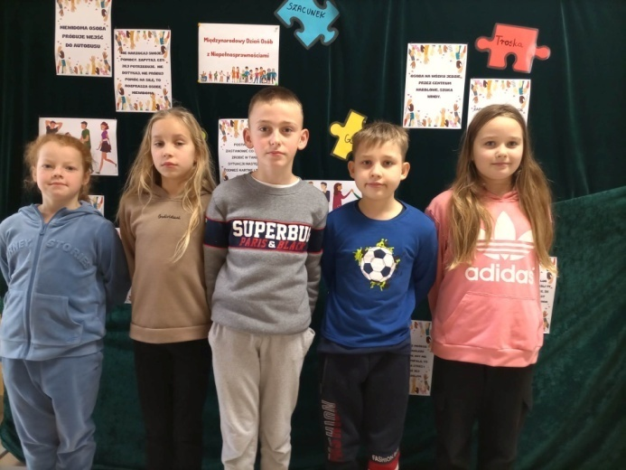
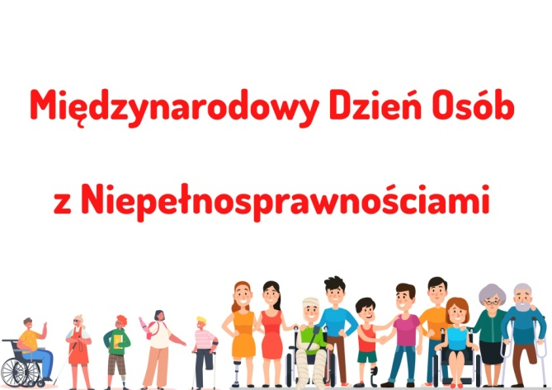

https://cloud-a.edupage.org/cloud?z%3A2982JCWGDtovyig3GLM3oWFDhbBqPnqjq8%2BVamAeUuU2ekogbH3ufzK6LHevsCAH

Kształtowanie szacunku do tradycji

A Mikołaj pędzi...wyjazd klas Oa Ob

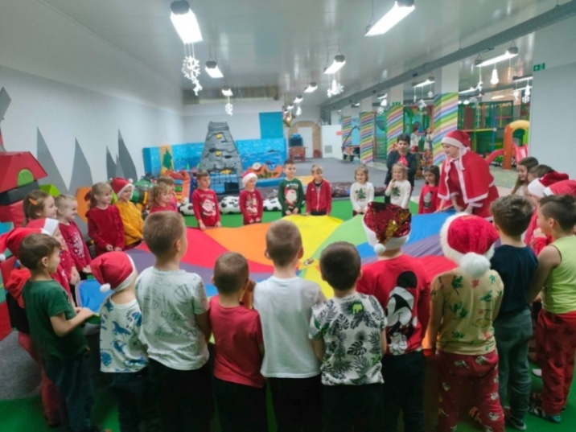
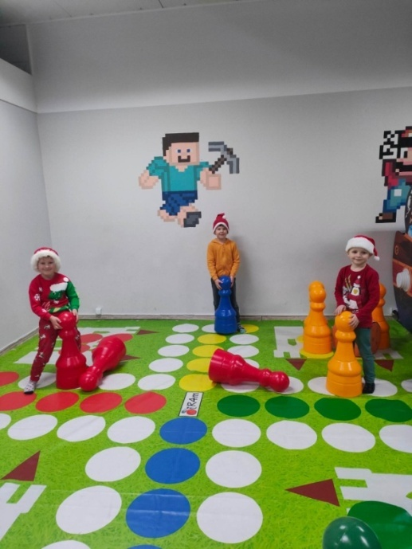

https://spborowa.edupage.org/news/?eqa=d2lkPW5ld3NfTmV3c18xX3AmbmV3c2FyY2hpdmVmPSZvZmZzZXRfbmV3c19OZXdzX

Mikołajkowy wyjazd szóstoklasistów
Integracja zespołów klasowych

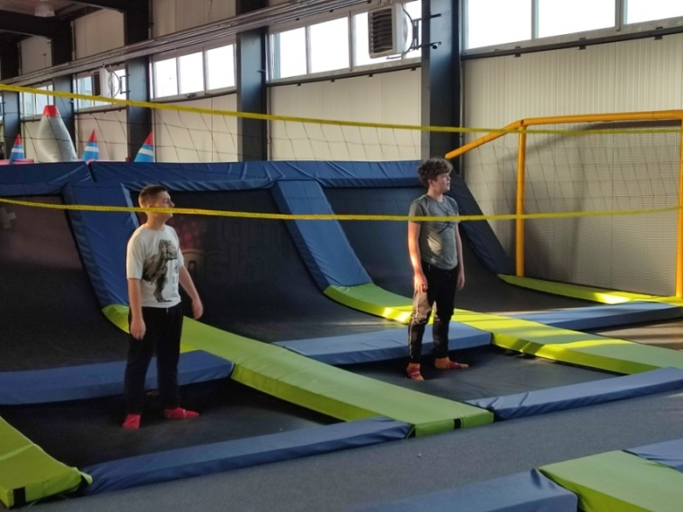
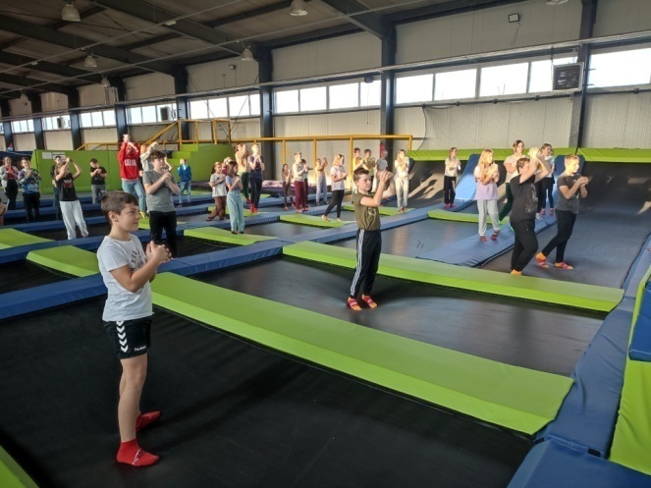

https://spborowa.edupage.org/news/?eqa=d2lkPW5ld3NfTmV3c18xX3AmbmV3c2FyY2hpdmVmPSZvZmZzZXRfbmV3c19OZXdzX

Wigilia z Mickiewiczem

Przedszkolne kolędowanie z patronem

Idą, idą kolędnicy!

Piernikowy zawrót głowy

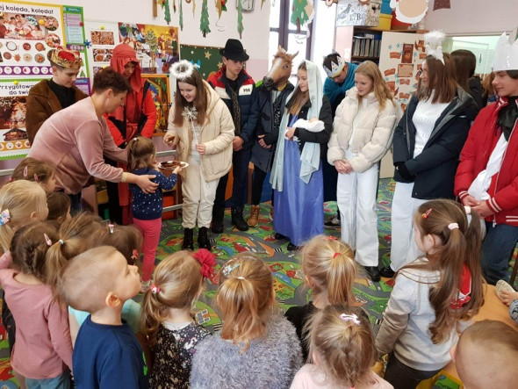
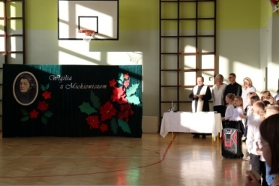

https://cloud-7.edupage.org/cloud?z%3AlH0jE30RsO7VrNdIcZxLLDDUdUHqGwQwCx4yhhDf%2By%2BlEYXm501YPybnJ%2BS%2BJAbW

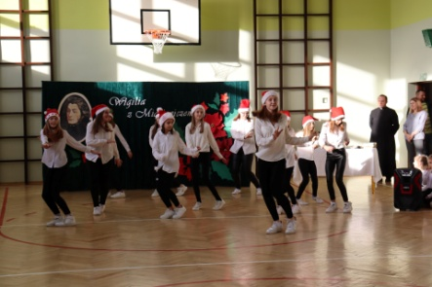

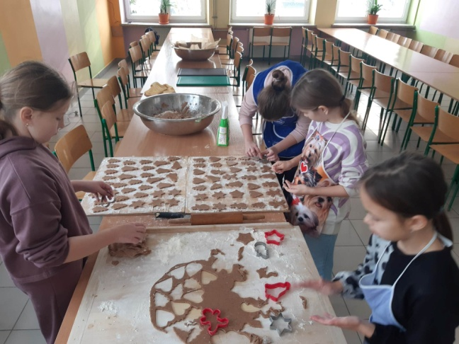

https://cloud-8.edupage.org/cloud?z%3AkE5Ony%2Bb1O%2FDm7%2Ftpnmzccdz2ScH4%2FAV4Uk0knHNEkzVKTzICJhxFpdxUjc9MMQC
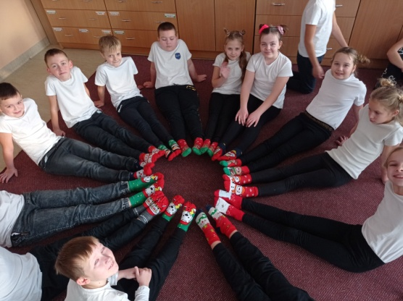
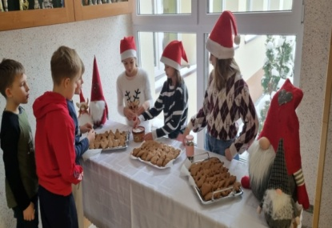
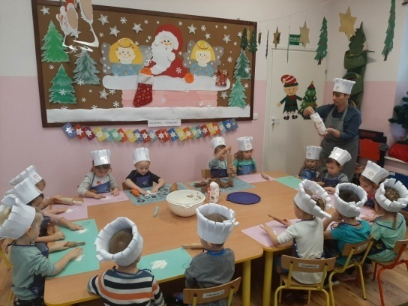
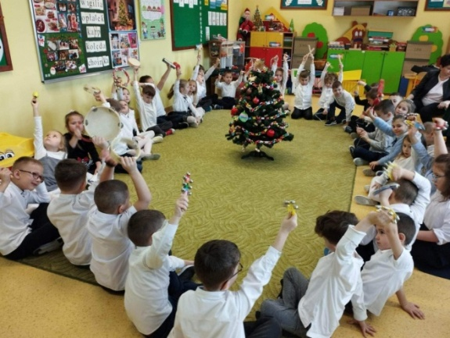

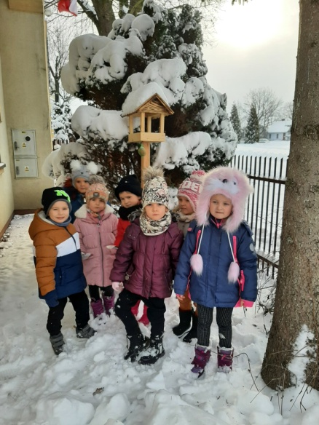
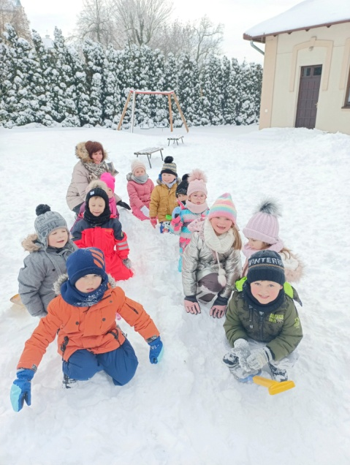

Uwrażliwianie na piękno otataczającego świata
My się zimy nie boimy...

Tworzenie przyjaznego klimatu w szkole
Mikołajkowy wyjazd do parku trampolin

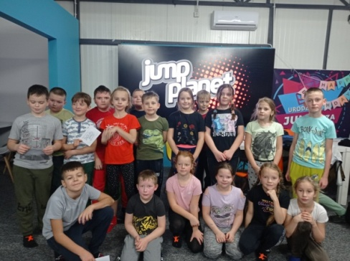
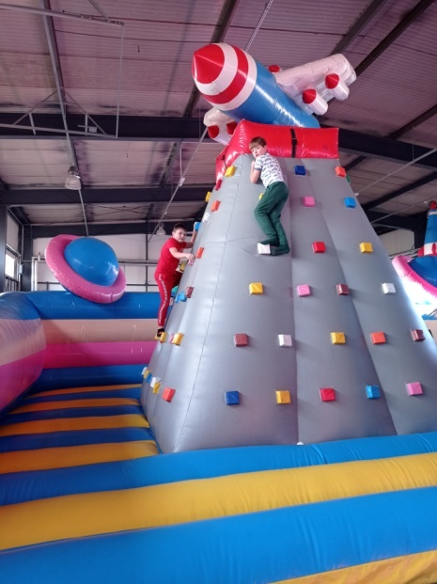

https://cloud-2.edupage.org/cloud?z%3Ajayw5dD2u%2FakeaxLhNtLGU%2FGJFAGxunvM5KOHK1yMziMUjmAFLz%2BA8r8V%2BCBfzRp

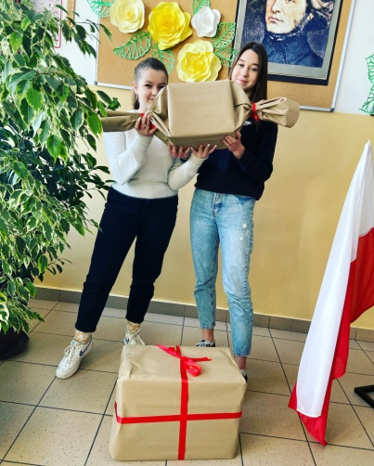
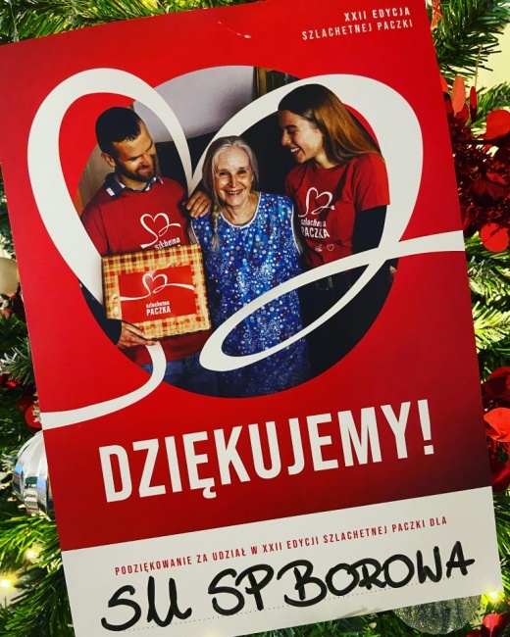

Szlachetna paczka 2022
Kształtowanie postaw prospołecznych

https://cloud-2.edupage.org/cloud?z%3Ajayw5dD2u%2FakeaxLhNtLGU%2FGJFAGxunvM5KOHK1yMziMUjmAFLz%2BA8r8V%2BCBfzRp

Świąteczne spotkanie w OREW w Woli Pławskiej
Działalność wolontariatu

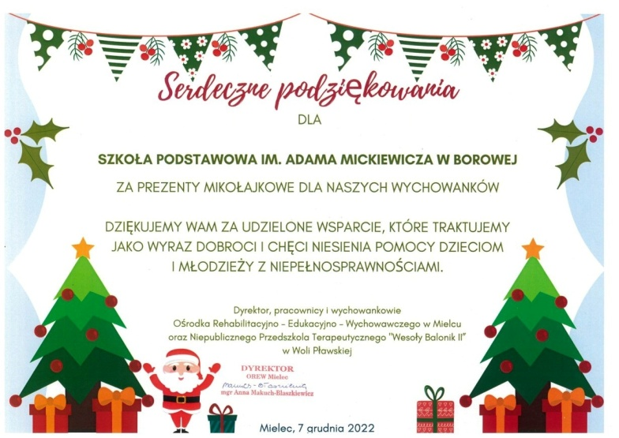
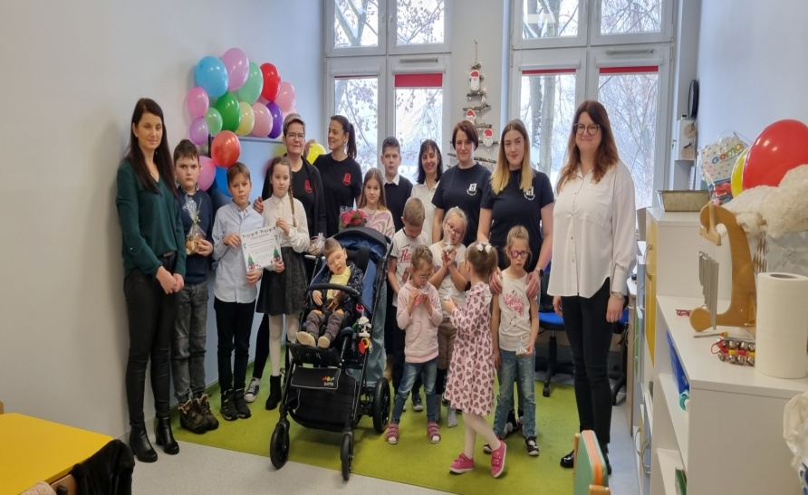

https://spborowa.edupage.org/news/?eqa=d2lkPW5ld3NfTmV3c18xX3AmbmV3c2FyY2hpdmVmPSZvZmZzZXRfbmV3c19OZXdzXzFfcD0

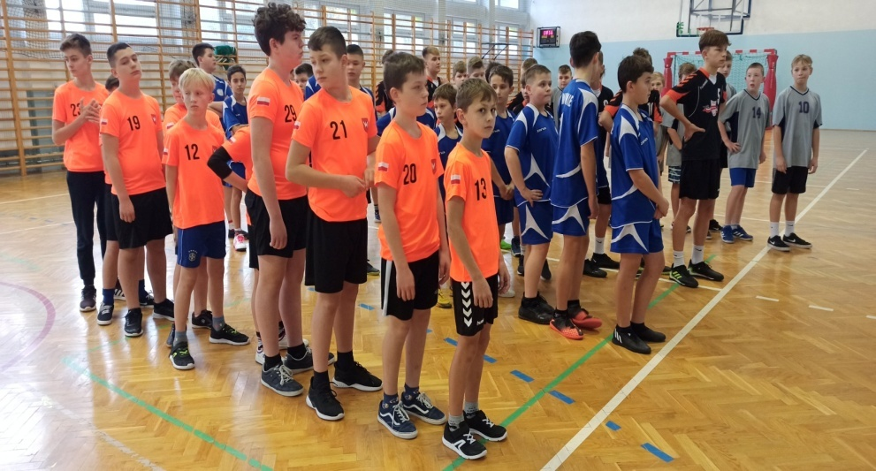
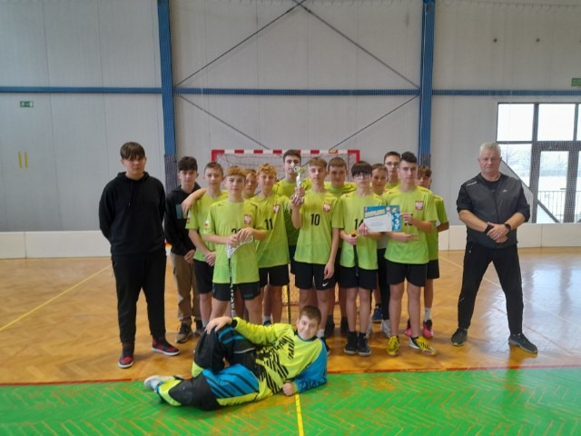
III miejsce drużyny chłopców IMS w koszykówce, IV miejsce młodych koszykarzy w zawodach ID w Maliniu
II miejsce chłopców w finale powiatowym IMS w unihokeju.

https://cloud-f.edupage.org/cloud?z%3AC92szidnXHF8M2CE2uN%2BRaQdNk%2FMRFCbmMLadx70I7kb5xOBAHwpRud%2Fk4X6SOMF

Promowanie zdrowego stylu życia
Program sportowy dla uczniów naszej szkoły „ Ruszaj się” – na basenie i siłowni w OSiR Połaniec.

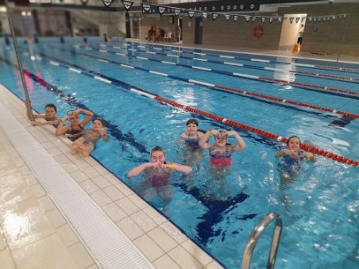
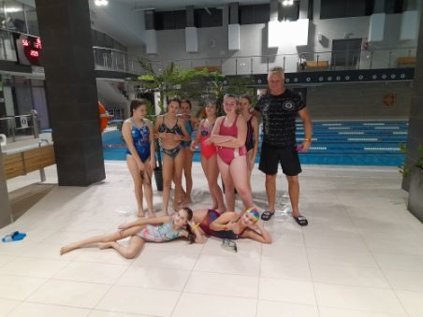

https://cloud-4.edupage.org/cloud?z%3A%2Bh4Rz8AH5xQLwSSKOoFsQBYivl3w%2FO5zZ3hriJ5Ily0As2IeLGGFL2MfThnbjQYF

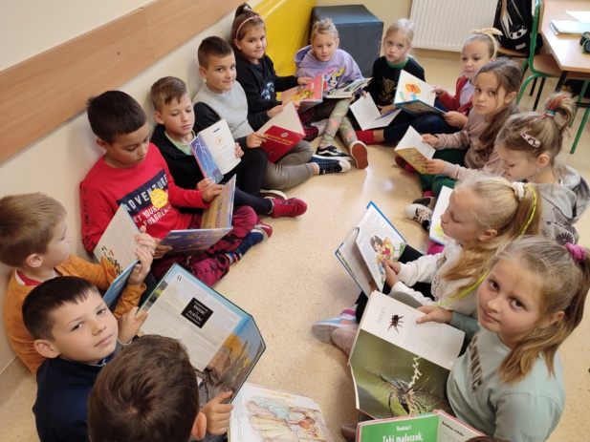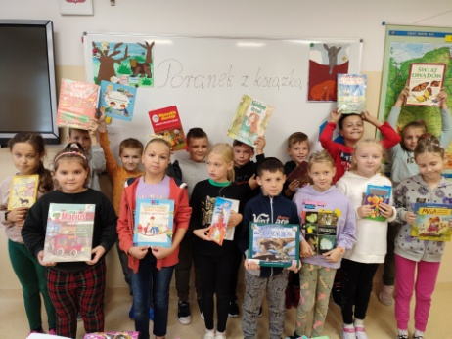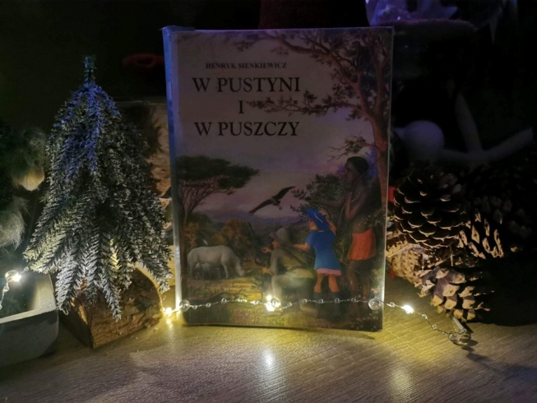

https://cloud-d.edupage.org/cloud?z%3ApLyPPGwfxerxThbOwISebe0%2FoNqI9qKc3twdwkPk3qGPEMAMyKYV63xMT%2B6M8YwQ
Projekt czytelniczy „Lubię czytać” klasy II a
„Poranek z książką" klasy II b
„Pokaż mi swoją książkę” - klasa VIb

